Game Design Document
Fill up the Following document

- Write the title of your project.
Senior Savior

- What is the goal of the game?
To help senior citizens in probing the web and provide various
services and data in a presentable and user-friendly manner.

- Write a brief story of your game?
Senior Citizens are not so well-versed with technology and cannot
explore the entire web. So with the app, they can learn new trends,
acquire information or facilities they require.

- Which are the playing characters of this game?
- Playing characters are the ones which respond to the user based on the input from the user
- Cars, monkeys, dinos, wizards etc, are the playing characters in the game.
Number | Character Name | What can this character do?
1 | User | The user can navigate through the app, interacting with various elements and information in order to retrieve information in a presentable and well-understood manner.

- Which are the Non Playing Characters of this game?
- Non Playing characters are the ones which don't have an action or a behaviour when the user interacts with the game.
- Hurdles, stones, bananas, coins, etc are non playing characters in the game.
Number | Character Name | What can this character do?
1 | Buttons | Buttons are used to interact with the app and select various options to get information.
2 | Pictures | Pictures are for visual understanding, used to make the facility easily understandable, like an image of yoga, depicting that the feature is for doing yoga.
3 | Drop-down Menus | Drop-down Menus are for selecting the parameters of the facility, like to find a hospital, the user has to select a city by a drop-down menu.
4 | Animations | Animations make the user feel more positive towards the app, for example displaying horoscope animations while the user is getting their daily horoscope.

- Draw your imagination of this game. What does this game look like?
- Draw the game either on your computer or on paper,
- Add images of scenes of the game to show each of the playing and non-playing characters at least once.
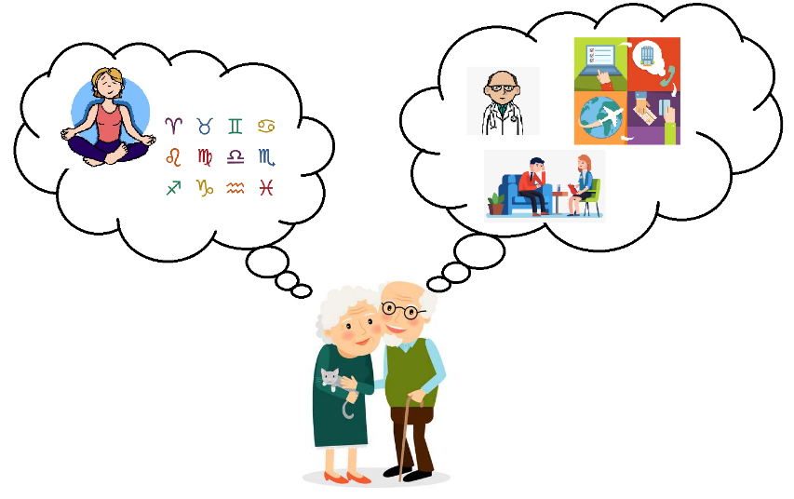

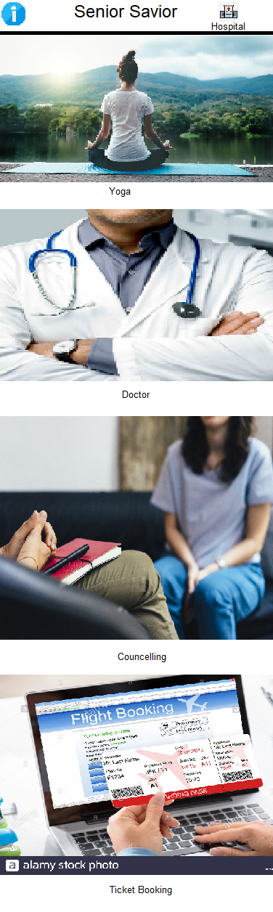

- How do you plan to make your game engaging?
The app would be comprehensible and user-friendly. The user will
obtain information "at his / her doorstep" in a manageable style.
The user can interact with the app to easily retrieve information.

